1)<!DOCTYPE html>

<html lang="en">

<head>

<meta charset="utf-8" />

<title>Newspaper</title>

<style>

table{

border:2px dashed yellow;

}

th,td{

border: 1px dotted red;

}

button{

cursor: pointer;

background: #44c4e7;

border: 0;

color: #fff;

font-family: "Calibri";

}

button:hover {

background: #369cb8;

}

p

{

color: darkred;

}

h2

{

color: brown;

}

</style>

<script>

function Create() {

var h = document.getElementById("heading1").value;

var c = document.getElementById("content1").value;

var a = document.getElementById("author1").value;

var d = new Date();

var x = document.createElement("ARTICLE");

x.setAttribute("id", "myArticle");

document.body.appendChild(x);

var heading = document.createElement("h1");

var txt1 = document.createTextNode(h);

heading.appendChild(txt1);

document.getElementById("myArticle").appendChild(heading);

var content = document.createElement("p");

var txt2 = document.createTextNode(c);

content.appendChild(txt2);

document.getElementById("myArticle").appendChild(content);

var author = document.createElement("h2");

var txt3 = document.createTextNode(a);

author.appendChild(txt3);

document.getElementById("myArticle").appendChild(author);

var date=document.createElement("p");

var txt4 = document.createTextNode(d);

date.appendChild(txt4);

document.getElementById("myArticle").appendChild(date);

}

</script>

</head>

<body background="white-paper-wrinkled-texture-background-white-paper-wrinkled-texture-background-white-crumpled-paper-texture-background-137375365.jpg">

<h1 align="center" style="color: black">E-Newspaper</h1>

<table align="center">

<tr>

<th style="color:black;">Heading:</th>

<td><input type="text" id="heading1" /></td>

</tr>

<tr>

<th style="color:white;">Content:</th>

<td><textarea cols="10" rows="5" id="content1" placeholder="Enter paragraph here"></textarea></td>

</tr>

<tr>

<th style="color:white;">Author:</th>

<td><input type="text" id="author1" /></td>

</tr>

<tr>

<td colspan="2" align="center"><button onclick="Create()">Submit your article</button></td>

</tr>

</table>

<p id="ad" align="left" > <img src="https://store.storeimages.cdn-apple.com/4982/as-images.apple.com/is/MXP72_VW_34FR+watch-44-alum-gold-nc-5s_VW_34FR_WF_CO?wid=750&hei=712&trim=1,0&fmt=p-jpg&qlt=80&op_usm=0.5,0.5&.v=1589938213000,1569365645172" style="height: 200px;width: 200px;"></p>

<h4>Get your new Apple WATCH TODAY!!!</h4>

<p id="ad" align="center"><img src="Fall Semester 2020-21/Internet and Web Programming Theory/IWP CLASS wORKS(tHEORY)/3-8-20/cj.jpg" style="height: 200px;width: 200px;" ></p>

<h4 align="center">New book from the Demo-God Out Now!!!</h4>

<p id="ad" align="right"><img src="Fall Semester 2020-21/Internet and Web Programming Theory/IWP CLASS wORKS(tHEORY)/3-8-20/ak.jpg" style="height: 200px;width: 200px;"></p>

<h4 align="right">Arkham Tank Simulator(aka GTA Arkham)OUT NOW ON XBOX,PS4 and not-Steam.</h4>

</body>

</html>

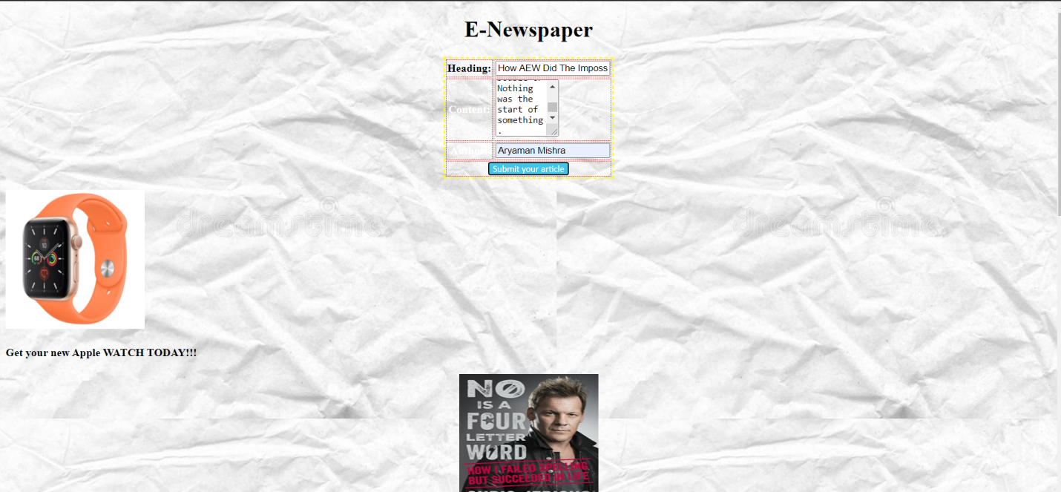

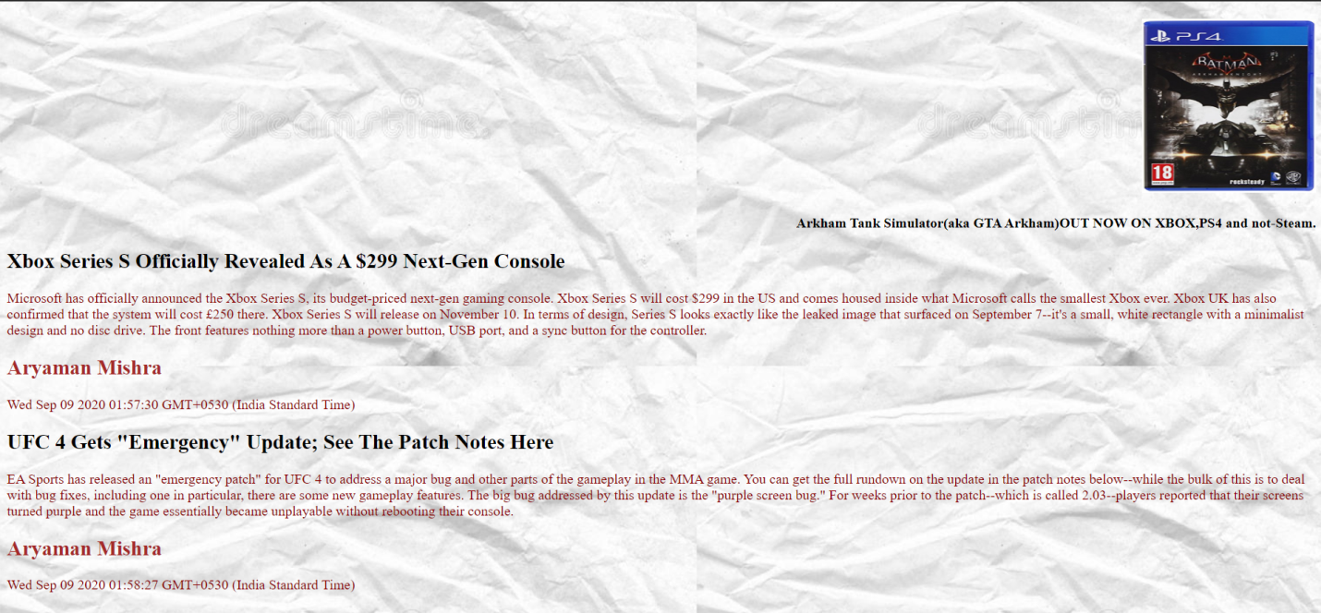

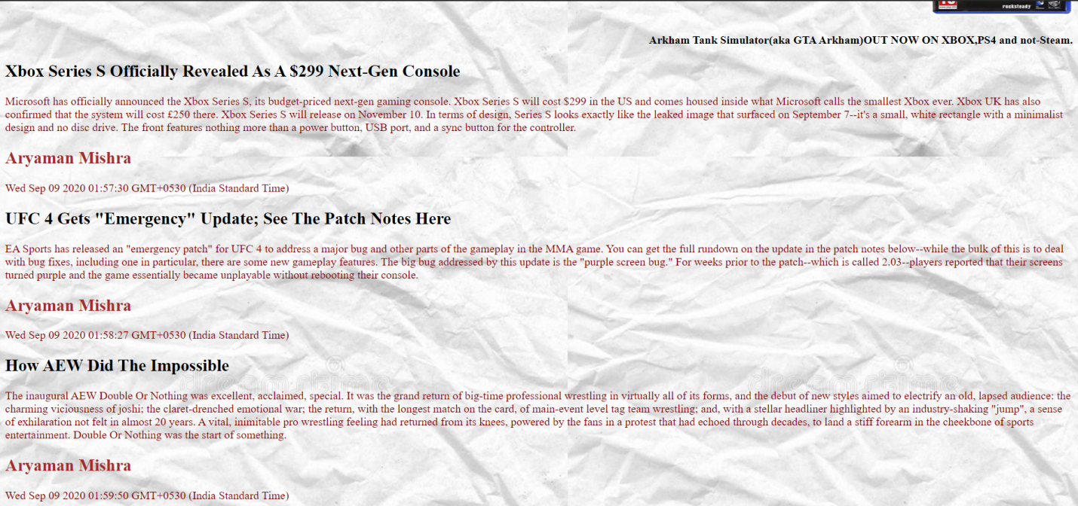

2) <!doctype html>

<html>

<head>

<meta charset="utf-8">

<title>Marketing Foundation</title>

<script>

var x=prompt("Enter number of bags of normal coffee.");

var y=prompt("Enter number of bags of decaffeinated coffee.");

var z=prompt("Enter number of bags of moha coffee.");

var m=prompt("Do you want to become a member of 'The Marketing Foundation?'");

var money=prompt("Enter money received from customer.");

var a=9*x;

var b=y*8;

var c=z*11;

var total=a+b+c;

var total1=0,total2=0;

var change;

if(total>100)

{

total=total-15;

}

if(m=="yes")

{

total1=total+50;

total2=(0.20)*total;

}

document.write("Summary:You purchased " + x +" bags of regular, totaling " + a +" dollars. You purchased "+y+" bags of decaf, totaling "+ b + " dollars. You purchased "+ z + " bags of mocha, totaling "+c+ " dollars. Your total purchase cost is "+ total + " dollars.");

document.write("<br />");

document.write("Bags of Regular Coffee:"+x);

document.write("<br />");

document.write("Price of Regular Coffee:"+a);

document.write("<br />");

document.write("Bags of Decaf Coffee:"+y);

document.write("<br />");

document.write("Price of Decaf Coffee:"+b);

document.write("<br />");

document.write("Bags of Mocha Coffee:"+z);

document.write("<br />");

document.write("Price of Mocha Coffee:"+c);

document.write("<br />");

document.write("Total Price of Coffee:"+total);

document.write("<br />");

document.write("Membership Fee:"+total2);

document.write("<br />");

document.write("Revised Price:"+total1);

document.write("<br />");

if(money>=total1)

{

change=money-total1;

document.write("Change Received:"+change);

document.write("<br />");

document.write("Thanks for Shopping at SunBucks!!!");

document.write("<br />");

}

else

{

document.write("Insufficient Money");

}

</script>

</head>

<body>

</body>

</html>

